Notes on PEEX Logo

PEEX Logo is the main piece of visual identity. It is a collaged image showing the Earth in flames. By default, it is accompanied by text in black and acronym in grey.
The current version is this:

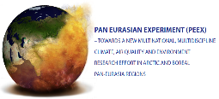
Shade
Lighter
text

Previously used versions.
Not current.

